**Change dns common address:**

**1. (Foreign) Google global dns address:**

**Preferred dnsS address: 8.8.8.8**

**Alternative dns address: 8.8.4.4**

**Windows 10 How to modify dns：**

**1. Right-click the wireless icon in the lower right corner of the desktop. If you plug in a network cable, the icon will be a little different. Click to open Network and Sharing Center.**

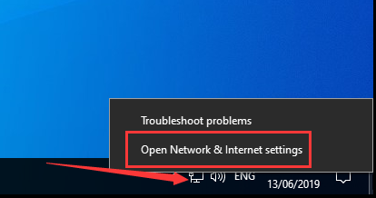  
1. Jump to the interface in the figure below and click Etheme on the left; if it is a wireless network, select a wireless network. Then click the red box option on the right;

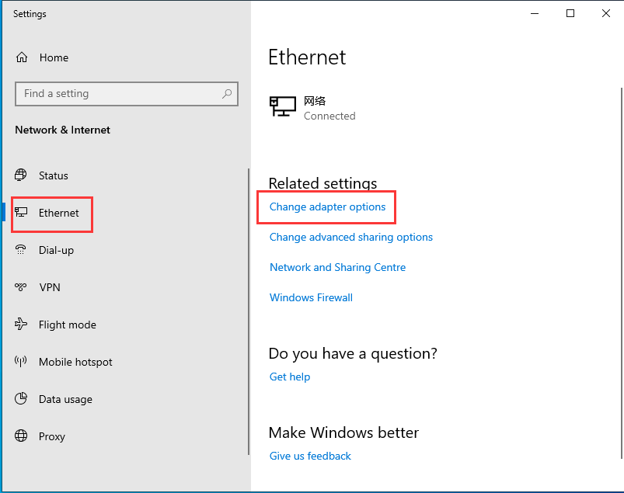

1. Right-click the icon of the currently connected network and click Properties.

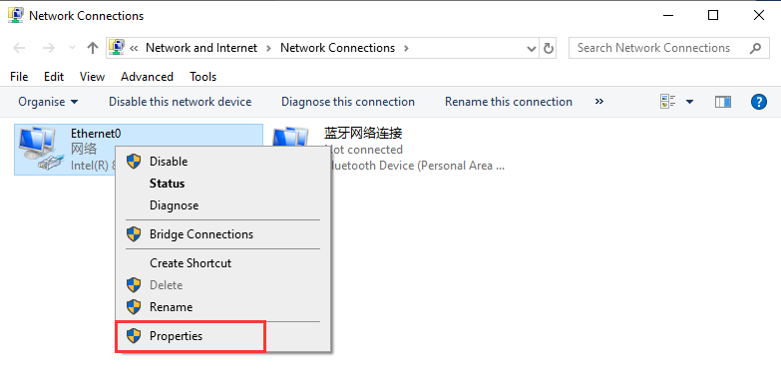

1. Find protocol version 4 on the property page and double-click it.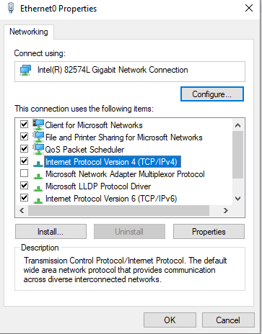

1. In the pop-up box, dns is automatically selected by default. You can change the settings on this page to modify dns!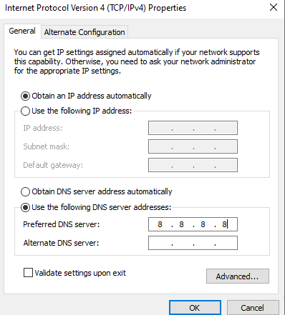

**How to modify dns on Mac:**

**1. First click on the System Preferences option**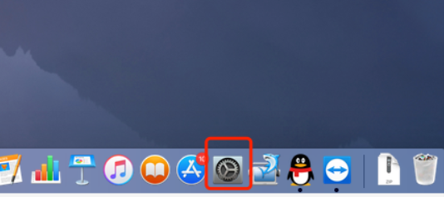

1. Then select the network option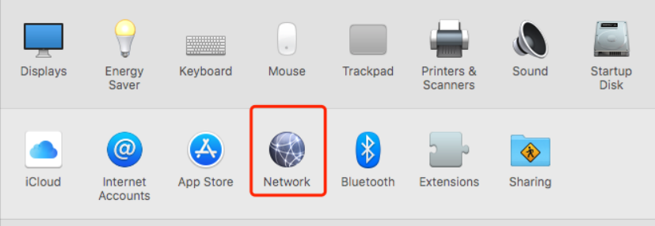

1. Click the Ethernet on the left and select the advanced option button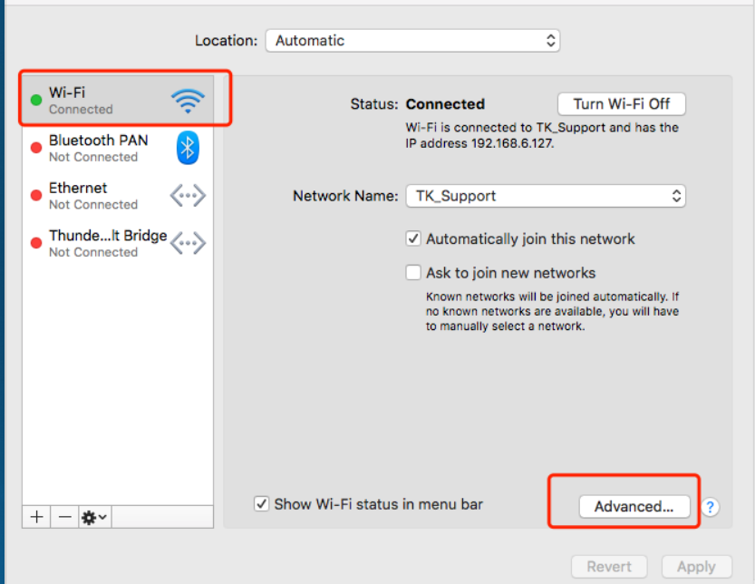

1. 1. Select DNS under Advanced Options and click the Add button below

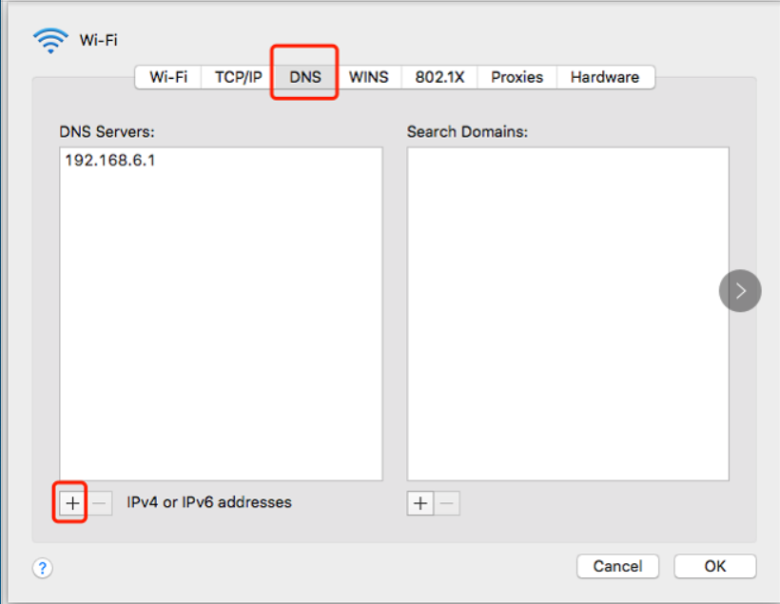

1. Manually set the DNS address you need, and then click the Apply button to save

